Sprint 2 - Accuracy Design Document

April 11, 2022

Table of Contents

1. Executive Summary 3

1.1 Project Overview 3

1.2 Purpose and Scope of this Specification 3

2. Product/Service Description 3

2.1 Product Context 3

2.2 User Characteristics 3

2.3 Assumptions 3

2.4 Constraints 3

2.5 Dependencies 4

3. Requirements 4

3.1 Functional Requirements 5

3.2 Security 5

3.2.1 Protection 5

3.2.2 Authorization and Authentication 6

3.3 Portability 6

4. Requirements Confirmation/Stakeholder sign-off 6

5. System Design 6

5.1 Algorithm 6

5.2 System Flow 6

5.3 Software 6

5.4 Hardware 6

5.5 Test Plan 7

5.6 Task List/Gantt Chart 7

5.7 Staffing Plan 7

# Executive Summary

## Project Overview

This project’s goal is to program a Sphero robot to complete an accuracy sprint. The robot must successfully complete a figure 8 course 5 times, change colors, and speak.

## Purpose and Scope of this Specification

It will complete the figure 8 course 5 times. It will speak “I am the winner” and flash multicolored lights for 5 seconds. It will finish in the starting location.

In scope

* Programming the Sphero robot to complete the accuracy sprint (a figure 8)
* Programming the robot to change colors and speak

**Out of Scope**

* It won’t collide with anything

# Product/Service Description

Robot will start from the square. Robot will complete the figure 8 course 5 times. Robot will speak “I am the winner” when it is finished. Robot will flash multicolored lights for 5 seconds. Robot will return to its starting location.

## Product Context

This project contains many interfaces. Sphero is used to create the block code, excel is used to create the Gantt chart, and Word is used to create the documents. It is Sprint 2 of a 3 Sprint project.

## User Characteristics

* Student
* Experience with coding
* Experience with a Sphero robot

## Assumptions

The room HH208 must be available to run the course. A Sphero robot is needed, the Sphero coding app is needed, and coding experience is needed. Must be able to record the robot.

## Constraints

Describe any items that will constrain the design options, including

* Room size
* Sphero coding
* Room availability

## Dependencies

List dependencies that affect the requirements. Examples:

* The project needs to be tested before recording it
* The code needs to be completed before testing it

# Requirements

The robot must successfully run the figure eight course 5 times. A path will be laid out on the floor. Your robot must stay within the path provided. The robot will start and finish in the square provided. The robot will speak ‘I am the winner’ and flash multicolored lights for 5 seconds after it completes the course. Robot will not stray from the path. Robot will stop in the starting location.

## Functional Requirements

| Req# | Requirement | Comments | Priority | Date Rvwd | SME Reviewed / Approved |
| --- | --- | --- | --- | --- | --- |
| ENDUR_01 | Start from the square | Starting location | 1 | 4-5-22 | Approved |
| ENDUR_02 | Stay in the path provided | Stay on the tape | 1 | 4-5-22 | Approved |
| ENDUR_03 | Speak “I am the winner” | Stopping speech | 2 | 4-5-22 | Approved |
| ENDUR_04 | Show multicolored lights for 5 seconds | Stopping colors | 2 | 4-5-22 | Approved |
| ENDUR_05 | Runs the course 5 times | How many times | 3 | 4-5-22 | Approved |
| ENDUR_06 | Does not hit anything | Cannot hit anything | 2 | 4-5-22 | Approved |
| ENDUR_07 | Stop in the starting location | Stopping location | 1 | 4-5-22 | Approved |
| ENDUR_08 | Complete it quickly | Quick and functions | 3 | 4-5-22 | Approved |

## Security

### Protection

* encryption
* activity logging, historical data sets
* restrictions on intermodule communications
* data integrity checks

### Authorization and Authentication

Verifies identity of user.

## Portability

* Code is on one computer, can be shared
* Cost of robot
* Robot battery
* Use of block code
* Sphero application

# Requirements Confirmation/Stakeholder sign-off

|  |  |  |
| --- | --- | --- |
| Meeting Date | Attendees (name and role) | Comments |
| 04/05/22 | Gianna Rao: Project Manager | confirmed all |
| 04/05/22 | Christopher Morandi: Functional Manager | confirmed all |

# System Design

## Algorithm

Code:

1. Start

2. Heading 0 degrees

3. Delay for 2 seconds

4. Speed 98

5. Spin 360 degrees for 4.7 seconds

6. Speed 0

7. Speed 96

8. Spin -360 degrees for 5.4 seconds

9. If figure 8’s completed < 5, repeat steps 4-8

10. Speed 0

11. Delay for 1 second

12. Speak “I am the winner”

13. Set mainLED to fade from red to blue over 2 seconds

14. Set mainLED to fade from green to pink over 2 seconds

15. Set mainLED to blue

16. End

Test the code and record the robot

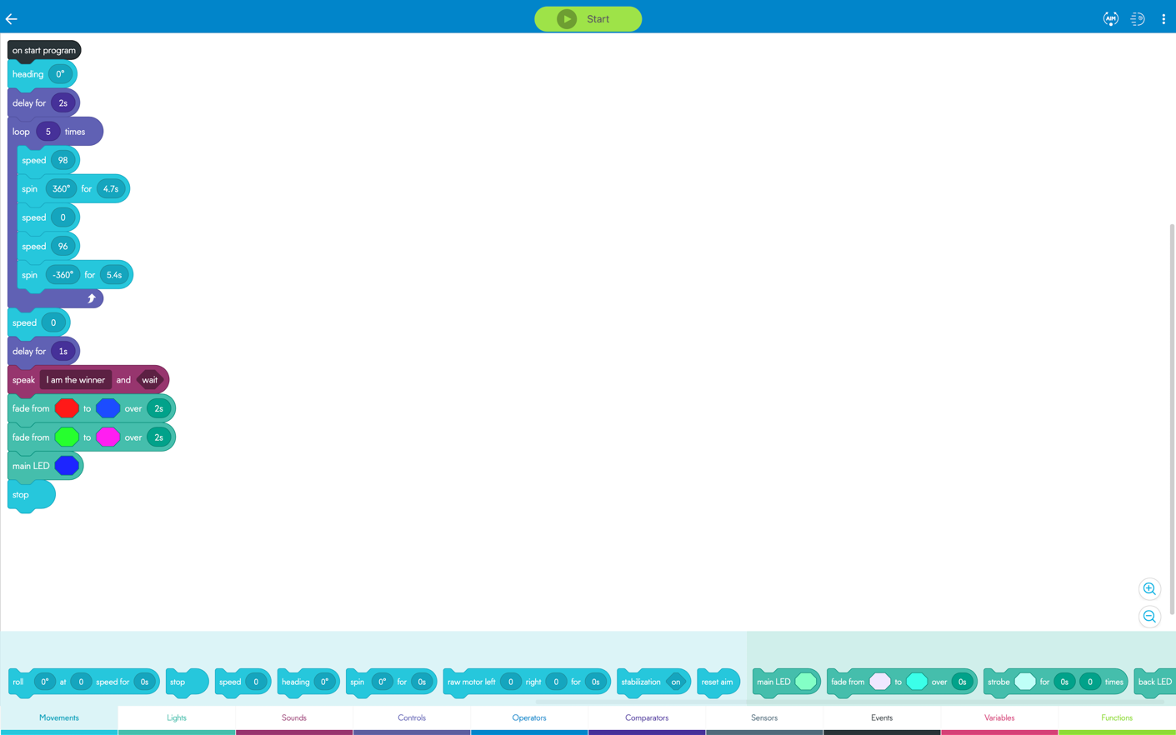

## System Flow

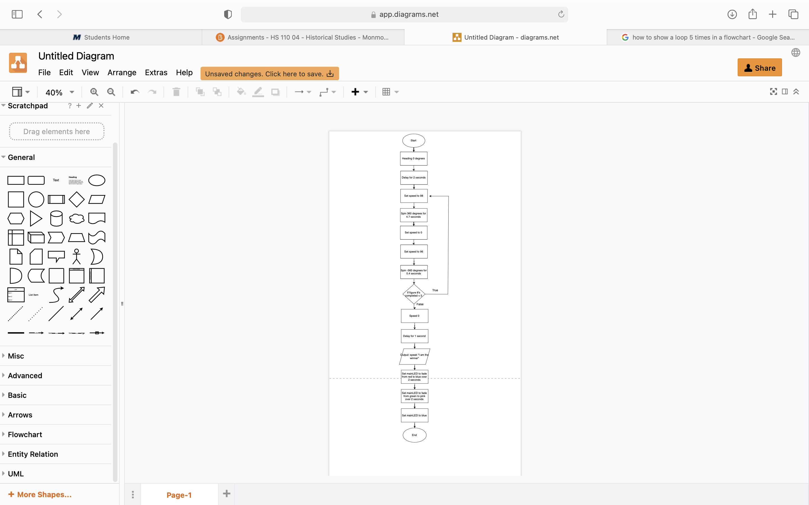

## Software

Sphero application and block code to program the Sphero robot.

## Hardware

MacBook Pro, iPhone to record, Sphero robot, room HH208’s course.

## Test Plan

Include a test plan showing all unit tests performed for this application, Include test rational, test date, staff member, pass/fail status

| **Reason for Test Case** | **Test Date** | **Expected Output** | **Observed Output** | **Staff Name** | **Pass/Fail** |
| --- | --- | --- | --- | --- | --- |
| Check if robot changes color correctly | 4-5-22 | Shows multicolored lights at the end | Shows multicolored lights at the end | Gianna Rao | Pass |
| Check if robot speaks correctly | 4-5-22 | Speaks “I am the winner” at the end | Speaks “I am the winner” at the end | Gianna Rao | Pass |
| Check if robot stays on the path provided | 4-5-22 | Stays on the tape | Goes too far | Gianna Rao | Fail |
| Check if robot stays on the path provided | 4-5-22 | Stays on the tape | Stays on the tape | Gianna Rao | Pass |
| Check if robot runs the course 5 times | 4-5-22 | Completes the course 5 times | Completes the course 5 times | Gianna Rao | Pass |
| Check if robot stops in the start location | 4-5-22 | Stops in the start location | Stops in the start location | Gianna Rao | Pass |

Sensor Data Diagram:

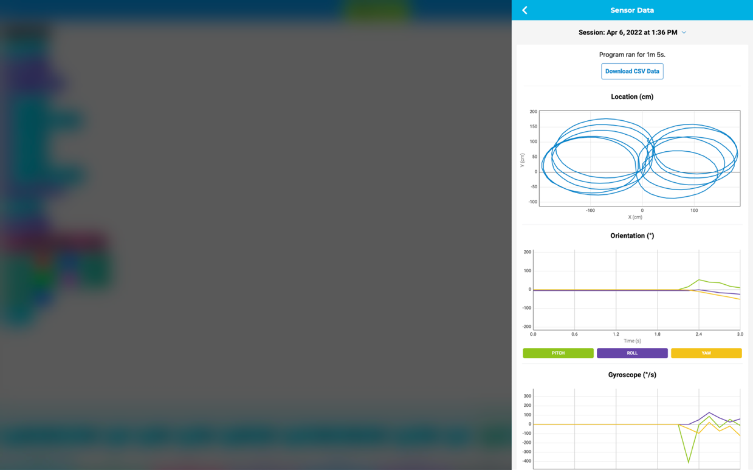

## Task List/Gantt Chart

## Staffing Plan

(next page)

| Name | Role | Responsibility | Reports To |
| --- | --- | --- | --- |
| Gianna Rao | Project Manager | Complete requirements of the project | Functional Manager |
| Christopher Morandi | Functional Manager | Make sure all requirements are completed | Project Manager |